Save Password History (Secure Local Storage)
mini password manager systems
This will add:
✔ Save generated passwords
✔ Store history in a file
✔ View previous passwords
✔ Timestamp logging
✔ Simple “password manager style” feature
Built using Python + file handling.

STEP 1 — Open File
nano gui_checker.py

💻 STEP 2:
import re
import random
import string
import tkinter as tk
from datetime import datetime

weak_passwords = ["123456", "password", "admin", "qwerty", "12345678"]

# SAVE FILE
def save_password(password, score):
with open("password_history.txt", "a") as f:
time = datetime.now().strftime("%Y-%m-%d %H:%M:%S")
f.write(f"{time} | {password} | Score: {score}/100\n")

# CHECK PASSWORD
def check_password():
password = password_entry.get()

score = 0
feedback = []

if len(password) >= 8:
score += 20
else:
feedback.append("• At least 8 characters")

if len(password) >= 12:
score += 10

if re.search(r"[A-Z]", password):
score += 20
else:
feedback.append("• Add uppercase letters")

if re.search(r"[a-z]", password):
score += 20
else:
feedback.append("• Add lowercase letters")

if re.search(r"[0-9]", password):
score += 15
else:
feedback.append("• Add numbers")

if re.search(r"[!@#$%^&*(),.?\":{}|<>]", password):
score += 15
else:
feedback.append("• Add special characters")

if password.lower() in weak_passwords:
score = 0
feedback.append("• Very common password")

if score >= 80:
result = "✅ STRONG PASSWORD"
elif score >= 50:
result = "⚠ MEDIUM PASSWORD"
else:
result = "❌ WEAK PASSWORD"

output_label.config(
text=f"{result}\nScore: {score}/100\n\n" + "\n".join(feedback)
)

# SAVE RESULT
save_password(password, score)

# GENERATE PASSWORD
def generate_password():
length = 16
chars = string.ascii_letters + string.digits + string.punctuation
generated = ''.join(random.choice(chars) for _ in range(length))

password_entry.delete(0, tk.END)
password_entry.insert(0, generated)

# COPY PASSWORD
def copy_password():
app.clipboard_clear()
app.clipboard_append(password_entry.get())
copy_label.config(text="✔ Copied to clipboard!")

# SHOW/HIDE PASSWORD
def toggle_password():
if password_entry.cget("show") == "*":
password_entry.config(show="")
toggle_btn.config(text="Hide Password")
else:
password_entry.config(show="*")
toggle_btn.config(text="Show Password")

# VIEW HISTORY
def view_history():
try:
with open("password_history.txt", "r") as f:
history = f.read()
except:
history = "No history found."

history_window = tk.Toplevel(app)
history_window.title("Password History")
history_window.geometry("400x300")

text = tk.Text(history_window)
text.pack(expand=True, fill="both")

text.insert("end", history)

# GUI
app = tk.Tk()
app.title("Cyber Password Tool v7")
app.geometry("520x500")
app.configure(bg="black")

# TITLE
title = tk.Label(
app,
text="CYBER PASSWORD SECURITY TOOL",
font=("Arial", 16, "bold"),
fg="lime",
bg="black"
)
title.pack(pady=10)

# ENTRY
password_entry = tk.Entry(
app,
width=35,
font=("Arial", 12),
bg="#111",
fg="lime",
insertbackground="lime",
show="*"
)
password_entry.pack(pady=10)

# BUTTONS
tk.Button(app, text="Check Password", command=check_password,
bg="#111", fg="lime", width=25).pack(pady=3)

tk.Button(app, text="Generate Password", command=generate_password,
bg="#111", fg="lime", width=25).pack(pady=3)

tk.Button(app, text="Copy Password", command=copy_password,
bg="#111", fg="lime", width=25).pack(pady=3)

toggle_btn = tk.Button(app, text="Show Password", command=toggle_password,
bg="#111", fg="lime", width=25)
toggle_btn.pack(pady=3)

tk.Button(app, text="View Password History", command=view_history,
bg="#111", fg="lime", width=25).pack(pady=3)

copy_label = tk.Label(app, text="", fg="lime", bg="black")
copy_label.pack(pady=5)

output_label = tk.Label(app, text="", fg="lime", bg="black", justify="left")
output_label.pack(pady=10)

app.mainloop()
STEP 3 — Run
python3 gui_checker.py
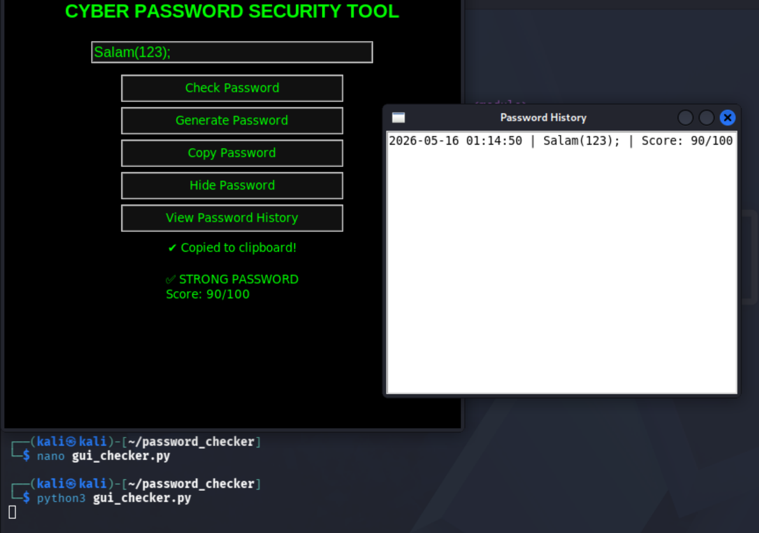
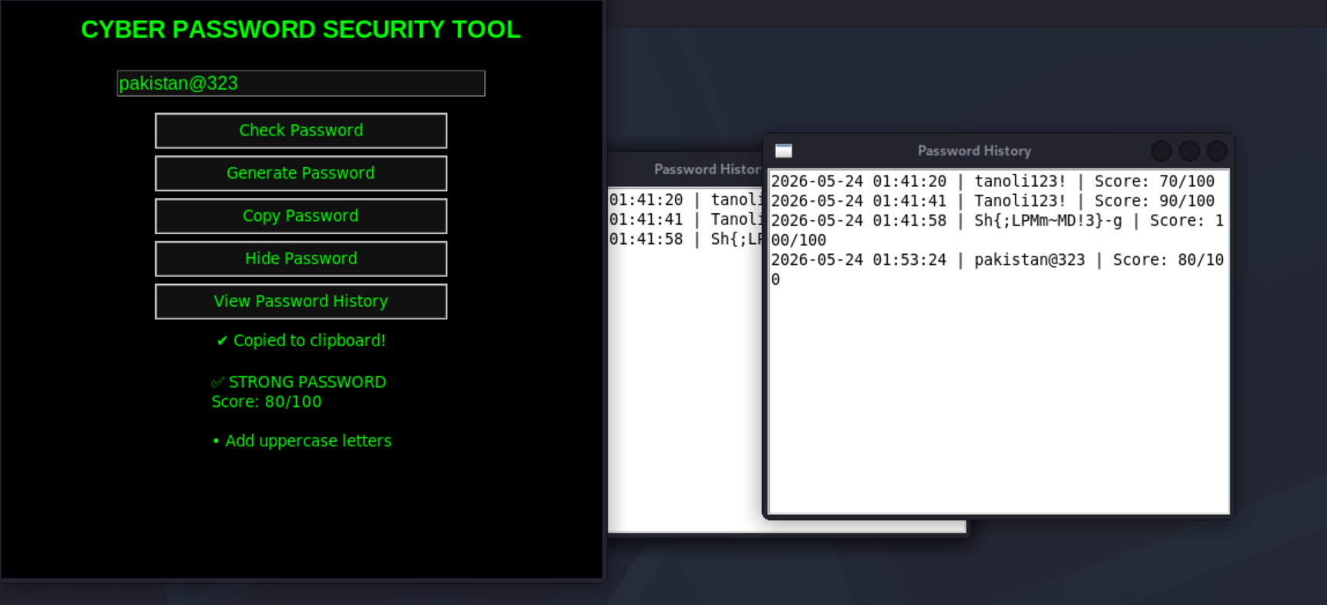

What gets created
A file:
password_history.txt
Example content:
2026-05-16 10:45:12 | Admin@123 | Score: 90/100
2026-05-16 10:46:05 | test123 | Score: 40/100

What we learned
✔ File handling (logging system)
✔ Timestamp tracking
✔ GUI multi-window system
✔ Basic password manager concept

